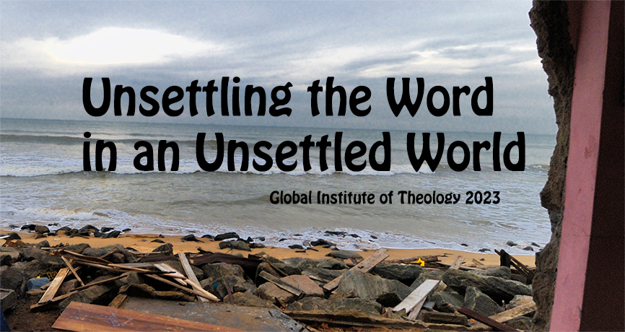

2023 GLOBAL INSTITUTE OF THEOLOGY (GIT)
15 to 30 June 2023 in Suva, Fiji

Application form
Please submit your completed application by 31 January 2023 to
World Communion of Reformed Churches, Knochenhauerstr. 42, 30159 Hannover, Germany
or by email: git@wcrc.eu or via fax: +49 511 8973 8311

The Admissions Committee will inform the applicants of their decision shortly after the application window closes. All other logistics (incl. registration, travel, and visa enquiries) will be addressed after admission.

Thank you for your interest in the GIT and we look forward to receiving your application!

Family name: First name(s):
Male/Female: Nationality:
Date of birth: Place of birth:
Postal address:

Email:
Tel (Country code/city code/number): Fax:
Academic institution:
Church affiliation:
Languages you speak apart from English (the working language of the GIT is English):

Why do you want to participate in the Global Institute of Theology?

Academic Background
Institution | Period | Degree

How do you plan to finance your participation in the institute?
The maximum amount to cover is 4900 euros (board and lodging 3000 euros, & tuition 1900 euros, in addition to individual travel costs). Each student is required to contribute a minimum of 100 euros to the GIT.

Source | Amount in Euros
Personal contribution
Church contribution
Seminary contribution
Sponsoring body
Other

PLEASE INCLUDE WITH YOUR APPLICATION
- A recent photo
- A 2-page narrative of your church engagement and the significance of theological studies for you, and
- Two letters of recommendation (one academic, one church: clergy or lay, approximately one page each)

_______________________________________________
Dated signature of applicant

_______________________________________________
Dated signature of church officer endorsing application

