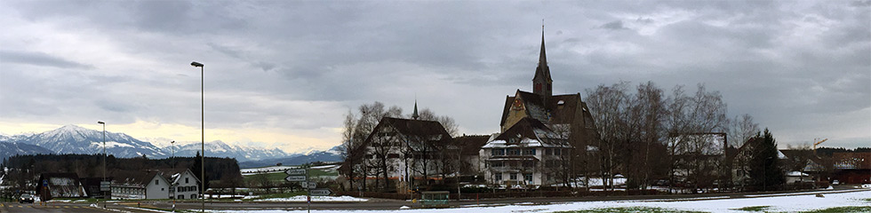

Executive Committee 2019: Evaluation Survey

G. The Executive Committee:
1. exercises general oversight of the work of the World Communion of Reformed Churches between meetings of the General Council including, but not limited to, the formation of departments, committees, and commissions to carry out the work of the World Communion of Reformed Churches.
2. authorizes the President and/or the General Secretary to speak for the World Communion of Reformed Churches between meetings of the General Council. The Executive Committee may, by way of exception and if needed, appoint one or more additional persons to speak for the World Communion of Reformed Churches.
3. performs all duties specified elsewhere in this Constitution and in the Bylaws or committed to it by the General Council.
4. has authority to approve the annual financial reports and adopt the annual budget.
5. fills vacancies among the officers and in its own membership, as specified in the Bylaws, which may occur between meetings of the General Council.
6. elects a General Secretary and appoints Executive Secretaries.
7. decides on admission to and suspension of membership in the World Communion of Reformed Churches subject to ratification by the next General Council.

—Article X, WCRC Constitution

By 31 May, please complete this form and return to Katrina Mertz (katrina.mertz@wcrc.eu) or take the survey online at: https://www.surveymonkey.com/r/excom2019

How did these factors contribute to the 2019 Executive Committee meeting?
Please rate the following aspects on how each assisted in the accomplishment of the 2019 Executive Committee meeting on a scale of 1 (needs a great deal of improvement) to 5 (no improvement needed) and add any comments for clarification:

- Preparations and Facilities

Necessary documents were available and distributed in a timely fashion | 1 2 3 4 5
Travel reservations/bookings were carried out in a timely fashion and in accordance to WCRC standards and protocols | 1 2 3 4 5
Adequate support was provided for any necessary visa acquisition | 1 2 3 4 5
Sufficient orientation was given for the proper functioning of the meeting | 1 2 3 4 5
In-country transportation was timely and efficient | 1 2 3 4 5
Meeting spaces were comfortable | 1 2 3 4 5
There were sufficient spaces for informal gatherings | 1 2 3 4 5
Coffee breaks were well-timed and provisioned | 1 2 3 4 5
The Wi-Fi was satisfactory | 1 2 3 4 5

Comments for clarification:

- Plenary Sessions
Please rate the following from 1 (needs a great deal of improvement) to 5 (no improvement needed on how each contributed to the overall work of the Executive Committee, keeping in mind time allotted and methodologies employed.

Address of the President | 1 2 3 4 5
Report of the General Secretary | 1 2 3 4 5
RAN/Chennai Process Update | 1 2 3 4 5
Mennonite Dialogue Introduction | 1 2 3 4 5
Ethical Investment Guidelines | 1 2 3 4 5
Reports & Greetings | 1 2 3 4 5
Decision Sessions | 1 2 3 4 5
Other Plenary Sessions | 1 2 3 4 5

Comments for clarification:

- Other Sessions
Please rate the following from 1 (needs a great deal of improvement) to 5 (no improvement needed), keeping in mind how each contributed to the overall work of the Executive Committee:

Discernment Sessions constructively contributed to everyone’s involvement in consensus building | 1 2 3 4 5
Sufficient time was given and materials provided to do the assigned work in Committee Meetings | 1 2 3 4 5
Regional Meetings strengthened bonds and addressed critical needs/issues | 1 2 3 4 5
The number, timing and styles of the various worship services and morning prayers contributed to the meeting | 1 2 3 4 5

Comments for clarification:

- Other Aspects
How well did these aspects contribute to the deepening of the work done at the Executive Committee, ranking from 1 (did not contribute much) to 5 (contributed a great deal):

Social Times | 1 2 3 4 5
Zwingli Film | 1 2 3 4 5
Zurich Outing | 1 2 3 4 5
Horgen Conference | 1 2 3 4 5

Comments for clarification:

- What was done best at the 2019 Executive Committee meeting?

- What is the one aspect that you most would like to see improved?

- Do you have any additional comments?

